 | 12.1.19 Editors - Geometry Nodes Editor - Header - Add Menu - Curve - Operations
Table of content
Detailed table of content 1
Add - Curve 4
Cuve to Mesh 4
Cuve to Points 5
Cuves to Grease Pencil 6
Deform Curves on Surface 6
Fill Curve 7
Fillet Curve 7
Interpolate Curves 8
Resample curve 9
Reverse Curve 10
Subdivide Curve 11
Trim Curve 11

Detailed table of content
Detailed table of content
Detailed table of content 1
Add - Curve 4
Cuve to Mesh 4
Inputs 4
Curve 4
Profile Curve 4
Scale 4
Fill Caps 4
Outputs 5
Mesh 5
Cuve to Points 5
Inputs 5
Curve 5
Properties 5
Mode 5
Evaluated 5
Count 5
Count Input 5
Length 5
Length Input 5
Outputs 5
Point 5
Tangent 5
Normal 6
Rotation 6
Cuves to Grease Pencil 6
Inputs 6
Curves 6
Selection 6
Instances as Layers 6
Outputs 6
Grease Pencil 6
Deform Curves on Surface 6
Inputs 6
Curves 6
Outputs 7
Curves 7
Fill Curve 7
Inputs 7
Curve 7
Group Input 7
Mode 7
Triangles or N-gons 7
Outputs 7
Mesh 7
Fillet Curve 7
Input 7
Curve 7
Count 8
Radius 8
Limit Radius 8
Mode 8
Bezier 8
Poly 8
Outputs 8
Curve 8
Interpolate Curves 8
Input 8
Guide Curves 8
Guide Up 8
Guide Group ID 9
Points 9
Points Up 9
Point Group ID 9
Max Neighbor 9
Outputs 9
Curves 9
Closest Index 9
Closest Weight 9
Resample curve 9
Input 9
Curve 9
Selection 9
Length 10
Mode 10
Evaluated 10
Count 10
Length 10
Count 10
Output 10
Curve 10
Reverse Curve 10
Inputs 10
Curve 10
Selection 10
Outputs 10
Curve 10
Subdivide Curve 11
Inputs 11
Geometry 11
Cuts 11
Outputs 11
Geometry 11
Trim Curve 11
Inputs 11
Curve 11
Selection 11
Start 11
End 11
Properties 12
Mode 12
Factor 12
Length 12
Outputs 12
Curve 12

Add - Curve
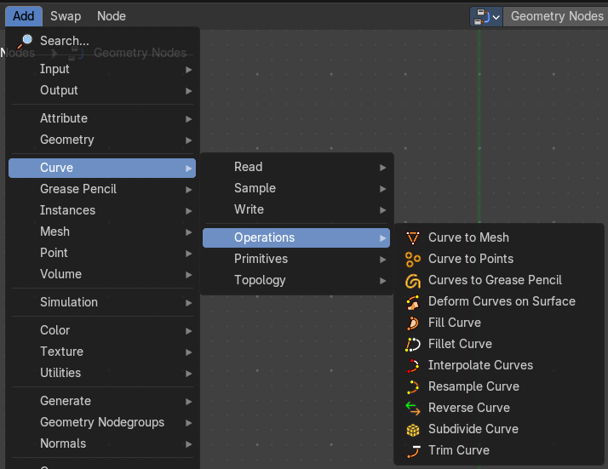
Here you find curve related nodes.

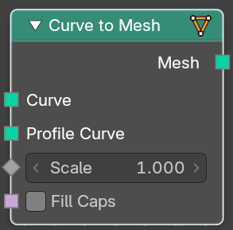
Cuve to Mesh
Converts a curve object to a mesh object. Optionally, a profile curve can be provided to give the curve a custom shape.

Inputs

Curve
The input curve.

Profile Curve
If a profile curve is provided, it will be extruded along all splines. Otherwise the generated mesh will just be a chain of edges.

Scale
Scale of the profile at each point.

Fill Caps
For cyclic profile curve. Fill the ends of the generated mesh for each spline combination with an N-gon.
The resulting mesh is Manifold, the two new faces for each spline are simply connected to existing edges.

Outputs

Mesh
Standard mesh output.

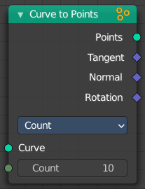
Cuve to Points
Converts a curve object to a Point cloud.

Inputs

Curve
The input curve.

Properties

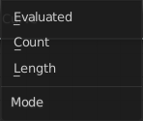
Mode
How to generate points from the input curve.


Evaluated
Create points from the evaluation points of the curve. This is based on the resolution attribute for nurbs and bezier splines.

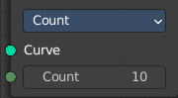
Count
Sample each spline by evenly distributing the specified number of points along the spline.

Count Input
The number of points to distribute along the spline.

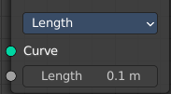
Length
Sample each spline by splitting the spline into segments by the specified length.

Length Input
The length of the single segments.

Outputs

Point
Generated point cloud.

Tangent
The normalized curve tangent at the sampled position, or the direct evaluated normal in Evaluated mode.

Normal
The normal value from the evaluated curve at each result point. This is the same value from the Normal Node at those positions.

Rotation

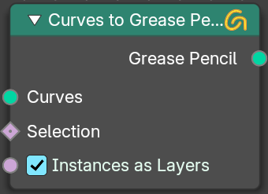
Cuves to Grease Pencil
Converts a curve object to a mesh object. Optionally, a profile curve can be provided to give the curve a custom shape.

Inputs

Curves
The input curves.

Selection
A selection of the curve

Instances as Layers
Create separate layers for each instance.

Outputs

Grease Pencil
Standard output.

The Euler rotation build from the Tangent and Normal outputs.

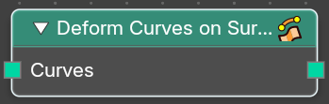
Deform Curves on Surface
Curves that are attached to a surface can follow the surface at modification.

Inputs

Curves
The input curve.

Outputs

Curves
The output curve.

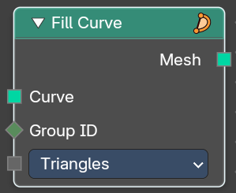
Fill Curve
Fills the curve with mesh geometry. The mesh is only generated flat with a local Z of 0.

Inputs

Curve
The input curve.

Group Input
An index used to rgoup curves together. Filling is done separately for each group.

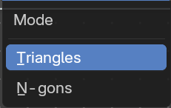
Mode

Triangles or N-gons
Fill the curve with either triangles, or use N-Gon geometry.

Outputs

Mesh
The output as mesh.

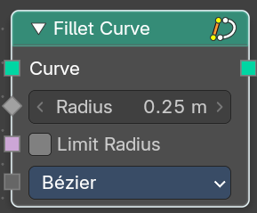
Fillet Curve
The Fillet Curve rounds corners on curve control points, similar to the effect of the Bevel Modifier on a 2D mesh.
A key difference is that the rounded portions created by the Fillet Curve node are always portions of a circle.

Input

Curve
The input curve.

Count
Polymode. Define the number of vertices that are created.

Radius
The radius of the arc

Limit Radius
Prevent overlapping when the defined radius exceeds the maximum possible radius for a given point.

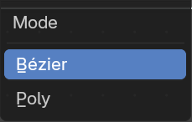
Mode

Bezier
Creates a circular arc at vertices by changing handle lengths (applicable only for Bezier splines).

Poly
Creates a circular arc by creating vertices (as many as defined by the Count fields input) along the arc (applicable for all spline types).

Outputs

Curve
Standard geometry input with a curve component.

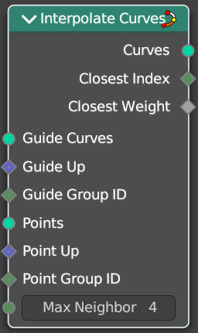
Interpolate Curves
Generates new curve parts by interpolating between existing curves.

Input

Guide Curves
The base curves to interpolate from.

Guide Up
An optional up vector that is typically a surface normal. Providing this up vector can improve the quality of the interpolation.

This up direction can be retrieved with a combination of the Sample UV Surface Node using the same geometry that the points were distributed on, and the Normal Node.

Guide Group ID
Splits guides into separate groups. New curves interpolate existing curves from a single group.

Points
The positions of the first root control points of the newly generated interpolated curves.

Points Up
Optional up vector that is typically a surface normal.

Point Group ID
The curve group to interpolate in.

Max Neighbor
Maximum amount of close guide curves that are taken into account for interpolation.

Outputs

Curves
The new curve.

Closest Index
Index of the closest guide curve for each generated curve.
Note that internally this node mixes the data from multiple guide curves, with the maximum number of sources depending on the Max Neighbor input. This output is only the index of the curve with the largest weight.

Closest Weight
Weight of the closest guide curve for each generated curve.

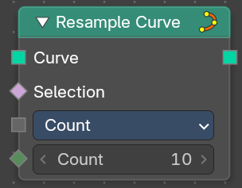
Resample curve
Creates a poly spline for each input spline. In the Count and Length modes, the control points of the new poly splines will have uniform spacing.

Input

Curve
The input geometry.

Selection
A selection of the input geometry

Length
The approximate length between the control points of the new splines.

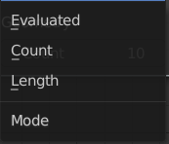
Mode
The resample mode.

Evaluated
Use the resolution attribute for spline and bezier curves.

Count
Use the count of the curve points.

Length
Use the length of the curve.

Count
The number of control points on the new splines.

Output

Curve
Standard geometry output.

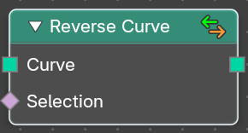
Reverse Curve
Reverses the direction of the spline. The start point becomes the end point and vice versa. The shape of the spline is not modified.

Inputs

Curve
The input curve.

Selection
An optional selection attribute to determine which part of the spline should be reversed.

Outputs

Curve
Standard geometry output.

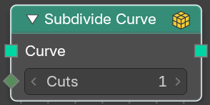
Subdivide Curve
Subdivides the curve. The shape is not changed.

Inputs

Geometry
The input curve.

Cuts
The number of cuts per segment.

Outputs

Geometry
Standard geometry output.

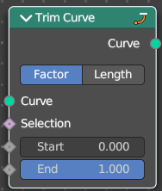
Trim Curve
The Curve Trim node shortens each spline in the curve by removing sections at the start and end of each spline.
Bézier splines will still output as Bézier splines. The first and last control point and its handles will be moved as necessary to preserve the shape. But NURBS splines will be transformed into poly splines in order to be trimmed.
Cyclic splines are currently not supported.
Note that if the Start input is larger than the End, then the resulting spline will have a single point, located at the sample location of the Start value.

Inputs

Curve
The input curve.

Selection
A selection of the curve.

Start
The start point of the spline, as a factor.

End
The end point of the spline, as a factor.

Properties

Mode
How to find endpoint positions for the trimmed spline.

Factor
The endpoint positions of each spline’s length is determined by a factor. The input values should be between 0 or 1.

Length
The endpoint positions of each spline is determined by a length from the start of each spline. The input values should be between 0 and the length of the splines.

Outputs

Curve
Standard geometry output.

